Web App & Backend development practical

Overview
This is a filter interview, and only if you demonstrate that you possess good practical solid skills will you be considered for the next phase of the interview.

You are required to complete the assignment and post it in your GitHub repository. Upon successful review, you will be invited to a virtual session to demonstrate your solution and answer follow up questions.

API Integration
API endpoints are documented in the Postman collection linked below. The collection provides details on:
- Request methods
- Required fields
- Example payloads
You may choose to consume the existing APIs provided in the Postman collection rather than building your own backend. Alternatively, you can implement new backend endpoints if preferred. Please indicate in your README which approach you are taking.

The assignment is broken down into two parts:
- Mobile/Web front-end development (60% Score)
- Backend development (40% Score)

Mobile/Web front end development

Assignment
Develop a web or a mobile application to register patients, take vitals ( Height & Weight and calculate the BMI), collect additional information via two custom forms and list the patient details. The application will contain five(5) pages, namely:
- Patient registration page
- Vitals form

Overweight Assessment Form
- General Assessment Form
- Patient Listing

Patient registration page
- Screen Mockup
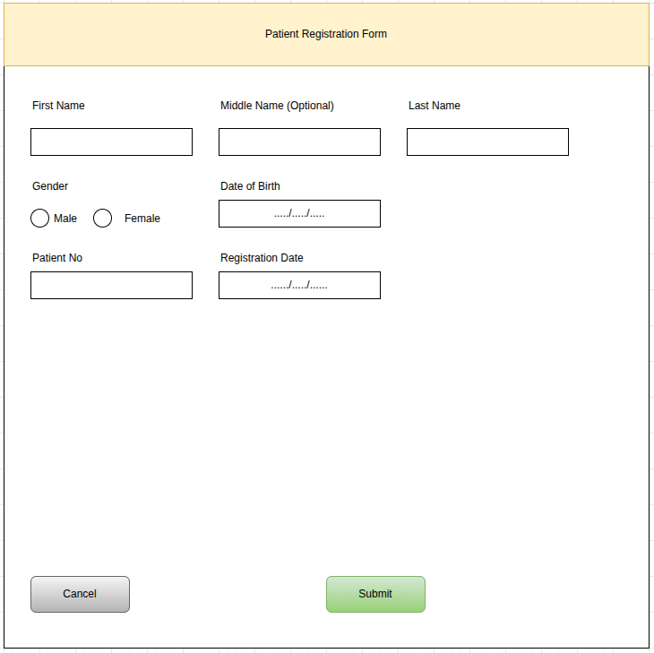
- It contains a Registration form that captures the following fields (3):
  - Patient Id (This is a unique field and cannot be shared between patients)
  - Registration date
  - First name
  - Last name
  - Date of birth
  - Gender
- A patient can only be registered once (1)
- Upon saving the Patient Registration details, load the Vitals page(1)

Vitals page
- Screen Mockup
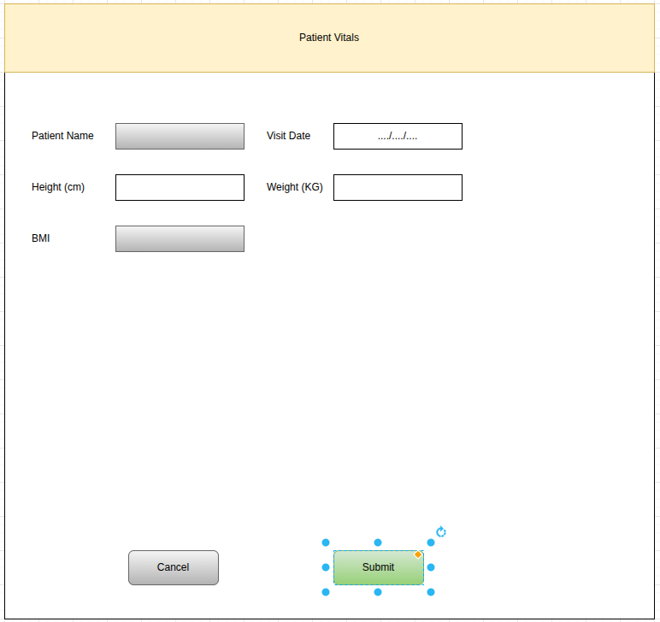

- It contains a Patient Vitals form that captures the following fields:
  - Visit Date
  - Height (In CM)
  - Weight (In KG)
  - BMI (This value is auto-calculated based on Height & Weight: ie. BMI = Weight(kg)/ Height(M)² )
- All fields are mandatory
- A single patient can have multiple submissions for the vitals form but on different dates.
- Upon saving the vitals form, if the patient’s BMI (BMI = kg/m2) is less or equal to 25, the app should automatically load General Assessment Form; otherwise, load Overweight Assessment Form.

Overweight Assessment Form
- Mockup
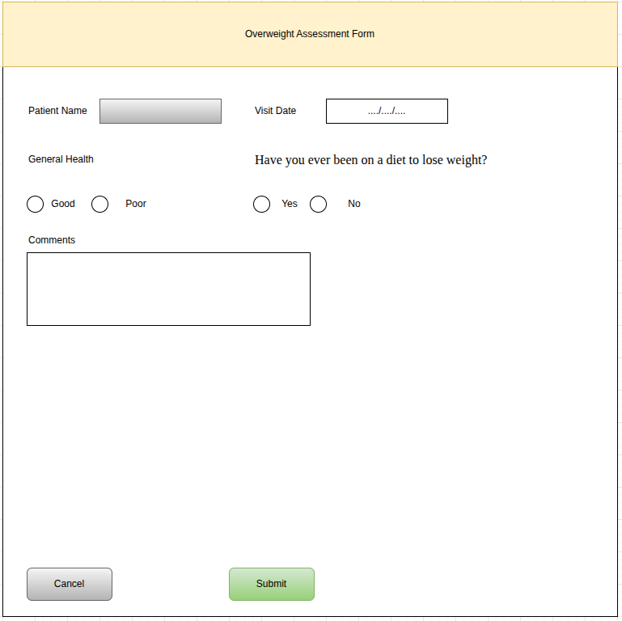
- Contains a form , which collects the following information:
  - Visit Date
  - General health (Good/Poor)
  - Have you ever been on a diet to lose weight? (Yes/No)
  - Comments
- A single patient can have multiple submissions for form A but on different dates.
- The page is only visible if BMI > 25
- All fields are mandatory
- Upon saving this form, load the patient listing page

General Assessment Form
- Screen Mockup
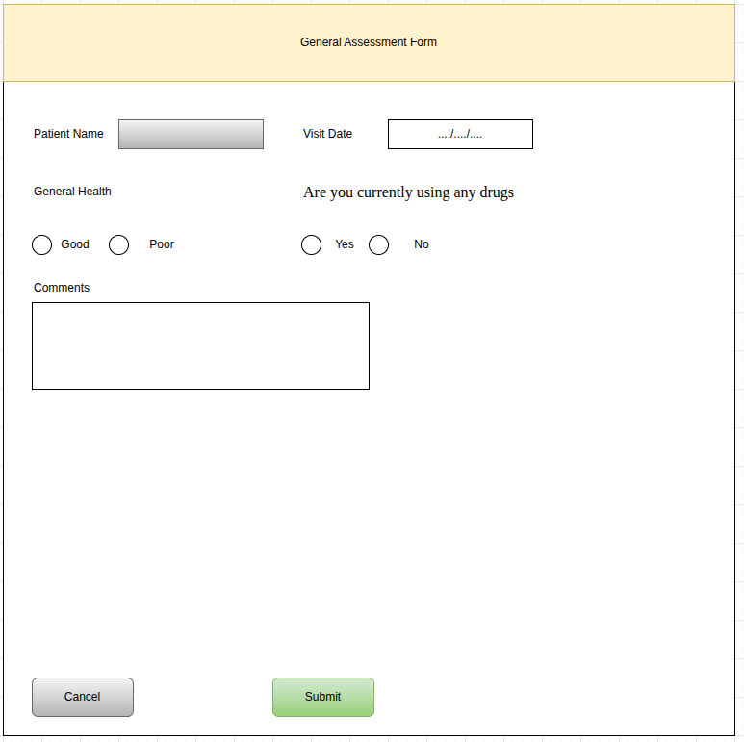

- Contains a form which collects the following information:
  - Visit Date
  - General Health (Good/Poor)
  - Are you currently using any drugs (Yes/No)
  - Comments
- A single patient can have multiple submissions for Visit form B but on different dates.
- Should only be displayed for patients whose BMI is equal to or less than 25
- Upon saving the form, load the patient listing page

Patient Listing Page
- Screen Mockup
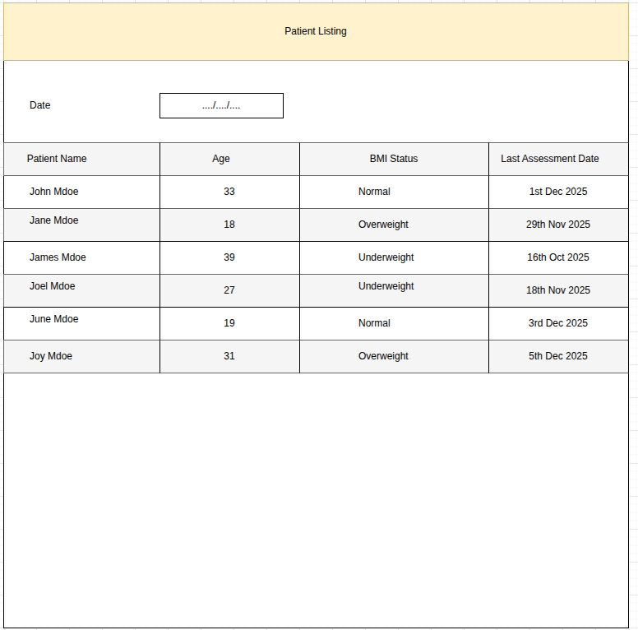
- Should display a list of patients showing the following columns:
  - Patient Name
  - Age
  - Last BMI Status
- Let the BMI status be either “Underweight”,” Normal”, or “Overweight”. Underweight patients have a BMI less than 18.5; Normal patients have a BMI greater than [or equal to?] 18.5 and less than 25, and greater or equal to 25 for overweight patients.
- The report should have the ability to filter records by the visit date.

Form submission
Upon saving the forms, the application should:
- Trigger data submission to a backend service that you will define in the next task.

Preferred Tech stacks
- For mobile Kotlin/Java
- Web: Technology of your choice

We will award bonus points for:
- Properly designed, functional and attractive UI

Backend development Assignment
Design and build a RESTful backend service capable of holding the information collected during the previous phase. The service should support the following end-points:
- Patient Registration
- Vitals
- Visit Forms

Preferred tech stack
Use any of the following Tech stacks:
Database
- MySQL, PostgreSQL, MongoDB
API
- Consider a technology of your choice.

We will award bonus points for a thoughtfully designed backend.

